A Grey Markov Prediction Method Optimized By GSA: Prediction of Agricultural Cold Chain Transportation Volume in China
Qiyong Yang¹ Jidan Huang¹ Tao Dai¹
¹ Glorious Sun School of Business and Management, Donghua Univeristy, Shanghai 200051, China
Correspondence: Jidan Huang huangjd@dhu.edu.cn
Abstract: Accurate prediction of frozen agricultural products logistics transportation volume is crucial for optimizing supply chain resource allocation. To solve problems of small sample sizes, nonlinear trends, and multiple influencing factors in the field, this study proposes a hybrid IGSA-Markov-FAGM(1,N) as prediction method. The model integrates Fractional-Order Accumulation Generation Operator (F-AGO) into GM(1,N) framework to emphasize the priority of new information and enhances nonlinear fitting ability, and Markov chain is also introduced to correct residuals, thus enhancing accuracy effectively. Meanwhile, Improved Gravitational Search Algorithm (IGSA) is used for optimization of parameter setting such as fractional order , weight factor and Markov state division thresholds. To verify the theory, 2013-2020 data of five Chinese agricultural-related indicators (including Primary Industry Added Value, Tertiary Industry Employees, etc.) are used as the training set to predict the frozen agricultural products logistics transportation volume from 2021 to 2024. Compared with the other four prediction methods that lack precision improvement measures, proposed hybrid prediction strategy demonstrates advantages in terms of MAPE, MAE, and MSE (MAPE of the hybrid strategy is 10.23%, while MAPE of the two methods using fractional-order prediction is 13.56% and 17.81%, and the MAPE of the ordinary GM method, regardless of whether Markov correction is applied or not, exceeds 50%). This study provides a reliable prediction tool for agricultural cold chain logistics management and offers scientific support for industrial policy formulation.
Keywords: Fractional-Order Adaptive Grey Prediction; Markov Residual Prediction; Improved Gravitational Search Algorithm (IGSA); Agricultural Logistics Transportation Volume.

1 Introduction
Recent years, with the acceleration of global agricultural industrialization and upgrading demand for fresh agricultural products, the cold chain logistics industry has become a crucial link in ensuring food safety, reducing post-harvest losses, and promoting the circulation of agricultural products (Chiang and Chang 2026). In China, the scale of agricultural cold chain logistics has expanded rapidly in recent years, but accurate prediction of logistics volume remains a challenge due to limitation of small sample data, nonlinear development trends, and multiple influencing factors, not only in agricultural industry (Haoxiang Li et al. 2024; H Li et al. 2024). Reliable forecasting can provide scientific support, resource allocation, and operational optimization, thereby improving the efficiency and sustainability of the entire supply chain (Schmid et al. 2025; Chen et al. 2025).
Prediction methods mainly include statistical models, machine learning models, and grey prediction models. Statistical models, including ARIMA(Bahadur et al. 2026; A et al. 2025) and its deformation method(Liu et al. 2026) require high-quality and large-scale data and strict assumptions about data distribution, which limit their applicability in small-sample and uncertain cold chain logistics systems. Machine learning (ML) models including LSTM (Lakshmanan et al. 2024; Wang et al. 2025), XG-Boost (Lu et al. 2025) usually show advantages in nonlinear fitting, and Neural Network (NN) is added to increase the accuracy of the prediction (Peddakapu et al. 2026; Shawon et al. 2025), but rely heavily on high-quality labeled data and have high computational complexity. The methods mentioned are less suitable for scenarios with small-scale datasets and incomplete information.
In contrast, grey system theory, proposed by Deng and mostly used in studies (Wu and Chen 2005), excels in handling small-sample, poor-information prediction problems by mining hidden patterns in data through accumulation generation operations, which has been widely applied in market(Wu et al. 2026), logistics (Nguyen et al. 2025), energy (K. Li et al. 2024; Wang et al. 2024; Tu et al. 2026a), and industry forecasting (Guo et al. 2026a).
The structure of this paper is structured as follows. Section 2 presents a literature review of grey prediction models, residual correction methods, and parameter optimization techniques. Section 3 details the methodology, including data preprocessing, FAGM(1,N) model establishment, Markov residual correction, and GSA-based parameter optimization. Section 4 conducts a case study, combining data of Chinese agricultural cold chain logistics volume and five key influencing factors, verifying the model’s effectiveness through comparative experiments. Section 5 concludes the study.

2 Literature Review

2.1 GM(1,N) Prediction
The GM(1,N) model, as a classic multivariate grey prediction model, has been used to analyze the impact of multiple factors on system behavior, which includes multiple related variables and one target for prediction (Zeng et al. 2016; Shang et al. 2024). However, traditional GM(1,N) has inherent drawbacks. (1) The first-order accumulation generation operator (1-AGO) cannot fully reflect the priority of new information, leading to insufficient utilization of recent data (Shen et al. 2024) ; (2) The fixed weight of the adjacent mean background value fails to adapt to the dynamic fluctuation characteristics of data (Li et al. 2022; Ren 2020); (3) The model lacks effective correction mechanisms for random residuals, resulting in reduced prediction accuracy for volatile sequences (Li et al. 2025a). Optimized prediction model for concrete dam displacement based on signal residual amendment.
Compared with other methods, Grey Model (GM) has certain advantages, and it has been proven by many studies. Anas et al. compare the accuracy of traditional methods with ML methods for short-term energy demand time series problems and clarified the application scenarios of each category (Mustafa and Al-Yozbaky 2025). For discrete time series data, GM is simple to understand and calculate, as it’s solved by differential equations. Zhou et al. incorporates seasonal factors and employed time series with different cycle lengths and unit times to forecast China’s import demand for petroleum, natural gas, and crude oil (Shi and Gu 2025). Xie adopts a discrete variable grey prediction method to forecast China’s total energy consumption, with Markov approach to predict trends in energy demand structure (Ma et al. 2025).

2.2 Prediction Residual Correction
To address these issues, scholars have proposed various improved grey models. Fractional-order grey models, also known as FGM(1,1), introduce fractional accumulation generation operators (F-AGO) to flexibly adjust the weight of historical and recent data (Tu et al. 2026b; Weng et al. 2025). Meanwhile, residual correction techniques such as Markov chains (Yuan et al. 2025; Li et al. 2025b) , Gauss Process (Yi et al. 2026) and Neural Network (NN) (Sfar et al. 2026) can effectively capture random fluctuations in sequences. All works are made to reduce the residual.

2.3 Model Parameter Search
In the previous text, we mentioned a series of methods for improving the accuracy of predictions. During this process, numerous parameters are usually involved. These parameters are often based on experience. However, in order to further enhance the effectiveness of the prediction, search optimization algorithms are introduced to make improvements. Intelligent optimization algorithms, e.g., PSO (Tseng and Le 2026; Guo et al. 2026b) and GWO (Wu et al. 2026; Xu et al. 2024) or machine learning methods including Transformer frame work and XG-Boost (Kotsompolis et al. 2026) are employed to optimize key parameters, avoiding subjective parameter setting (intelligent algorithm optimization).
Despite these advancements, existing studies still have gaps, especially in predicting agricultural cold chain logistics volume. Most multivariate grey models focus on single improvement directions (e.g., only fractional order or residual correction) and lack a comprehensive integration of multiple optimization mechanisms [19], and the interaction between fractional order accumulation, adaptive background values, and parameter optimization is rarely considered. Meanwhile, few studies specifically target the agricultural cold chain logistics scenario, where the coupling of multiple influencing factors and nonlinear trends is more complex. Therefore, developing a hybrid grey prediction model that integrates multiple optimization modules and adapts to agricultural cold chain logistics is needed.
To fill these research gaps, in this study we propose a fractional-order grey prediction method with residual correction: Markov-FAGM(1,N) model enhanced by the Improved Gravitational Search Algorithm (IGSA) for predicting agricultural cold chain logistics volume (IGSA-Markov-FAGM).
The core innovations of this study are as follows:
(1) Integrate fractional-order accumulation generation operator (FAGO) into the GM(1,N) framework to highlight the role of recent information.
(2) Construct an adaptive background value based on local data volatility to improve the model’s fitting ability for nonlinear sequences.
(3) Adopt GSA for global collaborative optimization of key parameters (fractional order ζ, weight adjustment factor C, Markov state division thresholds) to avoid subjective errors.
(4) Introduce Markov chain to correct residual random fluctuations, further improving prediction stability.
In the following text, mathematical methods will be presented in detail, and verify the accuracy of the results based on actual cases.

3 Methodology
This chapter introduces the proposed novel hybrid prediction model in detail. The model takes the multivariate grey system theory as the core framework, enhances the fitting ability of the basic model by introducing the Fractional-Order Accumulation Generation Operator (F-AGO) and adaptive background value, innovatively adopts the Improved Gravitational Search Algorithm (IGSA) for global collaborative optimization of key model parameters, and finally uses the Markov chain to correct the random fluctuations of the residual sequence, thus constructing an accurate prediction framework suitable for small-sample, nonlinear, and multivariate systems.

3.1 Fractional-Order Accumulation Generation Operator (F-AGO)
Let the system characteristic sequence to be predicted (dependent variable) be $X_{1}^{(0)}$, and its corresponding $N-1$ related factor sequences (independent variables) be $X_{j}^{(0)}$, together forming the original non-negative sequence set.
$$X_{j}^{(0)}=\left(x_{j}^{(0)}(1),x_{j}^{(0)}(2),…,x_{j}^{(0)}(n)\right), j=1,2,…,N$$ | (1)
Where $n$ is the sample size and $N$ is the total number of variables. To meet the basic conditions of grey modeling, the ratio test is first performed on the original sequence $X_{j}^{(0)}$.
$$σ(k)=\frac{x_{j}^{(0)}(k-1)}{x_{j}^{(0)}(k)}, k=2,3,…,n$$ | (2)
If all the ratios $σ(k)$ fall within the acceptable coverage interval $Θ=\left(e^{-\frac{2}{n+1}},e^{\frac{2}{n+1}}\right)$, the sequence is suitable for direct grey modeling. Otherwise, the original sequence needs to be transformed by introducing an optimal translation constant $c_{opt}$: $x_{j}^{(0)^{'}}(k)=x_{j}^{(0)}(k)+c_{opt}$, so that the transformed sequence can pass the ratio test.
The traditional grey model uses the First-Order Accumulation Generation Operator (1-AGO) to weaken randomness. To further explore the deep-seated information of the sequence and reflect the principle of new information priority, this study introduces the Fractional Accumulation Generation Operator (F-AGO). For the sequence $X_{j}^{(0)}$, its $ζ$-order accumulation generation sequence $X_{j}^{(ζ)}=\left(x_{j}^{(ζ)}(1),x_{j}^{(ζ)}(2),…,x_{j}^{(ζ)}(n)\right)$ defined as:
$$x_{j}^{(ζ)}(k)=\sum_{i=1}^{k}{\left({k-i+ζ-1 \atop k-i}\right)}x_{j}^{(0)}(i)=\sum_{i=1}^{k}{\frac{Γ(ζ+k-i)}{Γ(k-i+1)Γ(ζ)}}x_{j}^{(0)}(i), k=1,2,…,n$$ | (3)
Where $ζ>0$ is the fractional accumulation order, and $Γ(⋅)$ is the Gamma function. When $ζ=1$, FAGO degrades to the classic 1-AGO. By adjusting the value of $ζ$, the weight of historical data in modeling can be flexibly regulated. When $0<ζ<1$, the model pays more attention to recent information.

3.2 Establishment of Fractional Adaptive Grey Model (FAGM(1,N))

3.2.1 Construction of Adaptive Background Value
The traditional GM(1,N) model uses the adjacent mean generation sequence as the background value, and its fixed weight (0.5) cannot adapt to the dynamic fluctuation characteristics of data. This paper proposes an adaptive background value construction method, whose weight is determined by the local data volatility.
$$z_{1}^{(ζ)}(k)=ω(k)⋅x_{1}^{(ζ)}(k)+(1-ω(k))⋅x_{1}^{(ζ)}(k-1),k=2,3,…,n$$ | (4)
where the adaptive weight $ω(k)$ is calculated as follows:
$$ω(k)=\frac{δ(k)}{\sum_{i=2}^{n}{δ}(i)},δ(k)=\left|\frac{x_{1}^{(ζ)}(k)-x_{1}^{(ζ)}(k-1)}{x_{1}^{(ζ)}(k-1)}\right|$$ | (5)
$δ(k)$ characterizes the instantaneous relative fluctuation intensity of the sequence at time $k$. The greater the fluctuation, the higher the weight $ω(k)$ of the current value $x_{1}^{(ζ)}(k)$ in the background value, making the background value more consistent with the actual change trajectory of the sequence.

3.2.2 White Equation and Parameter Estimation
Based on the fractional accumulation sequence $X_{j}^{(ζ)}$ and the adaptive background value $z_{1}^{(ζ)}$, the whitenization differential equation of the fractional grey model FAGM(1,N) is established as follows.
$$\frac{dx_{1}^{(ζ)}(t)}{dt}+ax_{1}^{(ζ)}(t)=\sum_{j=2}^{N}{b_{j}}x_{j}^{(ζ)}(t)+b_{0}$$ | (6)
where $a$ is the system development coefficient, $b_{j}(j=2,...,N)$ is the grey action quantity of the driving variable $x_{j}^{(ζ)}$, and $b_{0}$ is the grey input term. By integrating the white equation over the interval $[k-1,k]$ and using the background value $z_{1}^{(ζ)}(k)$ to approximate the integral term, the discretized model equation is obtained.
$$x_{1}^{(ζ)}(k)-x_{1}^{(ζ)}(k-1)+az_{1}^{(ζ)}(k)=\sum_{j=2}^{N}{b_{j}}z_{j}^{(ζ)}(k)+b_{0}$$ | (7)
Where $z_{j}^{(ζ)}(k)=\frac{1}{2}(x_{j}^{(ζ)}(k)+x_{j}^{(ζ)}(k-1))$ is the background value of the driving variable (which can adopt a fixed mean value or an adaptive form similar to (3.2)). Substituting $k=2,3,...,n$ into equation (3.5), the matrix form is obtained.
$$Y=BΘ$$ | (8)
Where,
$$\begin{matrix} \\ \end{matrix} Y=\left[\begin{matrix}x_{1}^{(ζ)}(2)-x_{1}^{(ζ)}(1) \\ x_{1}^{(ζ)}(3)-x_{1}^{(ζ)}(2) \\ ⋮ \\ x_{1}^{(ζ)}(n)-x_{1}^{(ζ)}(n-1) \\ \end{matrix}\right],B=\left[\begin{matrix}-z_{1}^{(ζ)}(2) & z_{2}^{(ζ)}(2) & ⋯ & z_{N}^{(ζ)}(2) & 1 \\ -z_{1}^{(ζ)}(3) & z_{2}^{(ζ)}(3) & ⋯ & z_{N}^{(ζ)}(3) & 1 \\ ⋮ & ⋮ & ⋱ & ⋮ & ⋮ \\ -z_{1}^{(ζ)}(n) & z_{2}^{(ζ)}(n) & ⋯ & z_{N}^{(ζ)}(n) & 1 \\ & & & & \end{matrix}\right]$$ | (9)

$$Θ=[a,b_{2},b_{3},…,b_{N},b_{0}]^{T}$$ | (10)
The parameter vector $Θ$ can be estimated by the Ordinary Least Squares (OLS) method.
$$Θ=(B^{T}B)^{-1}B^{T}Y$$ | (11)

3.2.3 Time Response Sequence and Prediction Value Reduction
Solving the differential equation (3.4), the time response formula of the fractional accumulation value of the characteristic sequence is:
$${​​​x}_{1}^{(ζ)}(k)=\left(x_{1}^{(ζ)}(1)-\frac{\sum_{j=2}^{N}{b_{j}}{​​​​x}_{j}^{(ζ)}(k)+b_{0}}{a}\right)e^{-a(k-1)}+\frac{\sum_{j=2}^{N}{b_{j}}{​​​​x}_{j}^{(ζ)}(k)+b_{0}}{a},k=2,3,…$$ | (12)
${​​​​x}_{j}^{(ζ)}(k)$ can take the mean value of the driving variable over the interval $[1,k]$ or other smooth estimates. To obtain the predicted value on the original scale, the Fractional Inverse Accumulation Generation Operator (F-IAGO) needs to be applied to ${​​​X}_{1}^{(ζ)}$.
$${​​​x}_{1}^{(0)}(k)=\sum_{i=0}^{k-1}{(}-1)^{i}\frac{Γ(ζ+1)}{Γ(i+1)Γ(ζ-i+1)}{​​​x}_{1}^{(ζ)}(k-i),k=1,2,…,n$$ | (13)
Where ${​​​x}_{1}^{(0)}(1)=x_{1}^{(0)}(1)$.

3.3 Markov Prediction Error Correction
After obtaining the optimal parameters of the FAGM(1,N) model through GSA optimization, the relative residual sequence on the training set can be calculated.
$$ε(k)=\frac{x_{1}^{(0)}(k)-{\hat{x}}_{1}^{(0)}(k)}{x_{1}^{(0)}(k)}×100\%, k=1,2,…,n_{train}$$ | (14)
Using the optimal state division thresholds ${​d}_{0}^{*},d_{1}^{*},d_{2}^{*},...,d_{m-1}^{*},d_{m}^{*}​$ synchronously optimized by GSA, the relative residual sequence is divided into $m$ states.
$$S_{1}:(d_{0}^{*},d_{1}^{*}],​S_{2}:(d_{1}^{*},d_{2}^{*}],​…,​S_{m}:(d_{m-1}^{*},d_{m}^{*})$$ | (15)
Among the upper and lower limits of these intervals, we have $d_{0}^{*}=-max\left|ε\left(k\right)\right|,when ε\left(k\right)<0$ and $d_{m}^{*}=max\left|ε\left(k\right)\right|, when ε\left(k\right)>0$, which indicates that $ε\left(k\right)∈[d_{0}^{*},d_{m}^{*}]$. Then, based on the state transition of residuals in the training set, an $m×m$ state transition probability matrix $P_{Markov}=[p_{uv}]$ is constructed.
$$p_{uv}=\frac{N_{uv}}{\sum_{w=1}^{m}{N_{uw}}},u,v=1,2,…,m$$ | (16)
$N_{uv}$ is the frequency of transition from state $S_{u}$ to state $S_{v}$.
For the prediction step $t$, the initial predicted value ${​​​x}_{1}^{(0)}(t)$ is first obtained using the FAGM(1,N) model, and the most likely state $S_{u}$ corresponding to its residual is determined. Then, according to the $u$-th row in the transition matrix $P_{Markov}$, the state $S_{v}$ with the highest probability is selected as the residual state result of the next period. After the state is predicted, the value of the residual can be obtained through the interval corresponding to the state. Generally speaking, the central value $C_{v}$ of the interval corresponding to the state is selected as the correction amount of the predicted residual, but in this study, we believe that taking the midpoint of the interval is not the most accurate method, and we will find the corresponding result through the following formula.
$$C_{v}=C×d_{v-1}^{*}+\left(1-C\right)×d_{v}^{*},v∈[1,m]$$ | (17)
Finally, the predicted value corrected by Markov is:
$${\hat{x}}_{1}^{(0)}​_{final}(t)={\hat{x}}_{1}^{(0)}(t)×\left(1+\frac{C_{v}}{100}\right)$$ | (18)
Based on the above content, we can summarize the solution process. Firstly, the FAGM(1,N) model is constructed by using the fractional-order cumulative F-AGO, and it differs from the traditional adjacent mean sequence. We have constructed an adaptive background value sequence and solved it using the OLS method. In the part of residual correction, we use the Markov chain to predict the state of the residuals. The specific flowchart is presented in Figure 1.
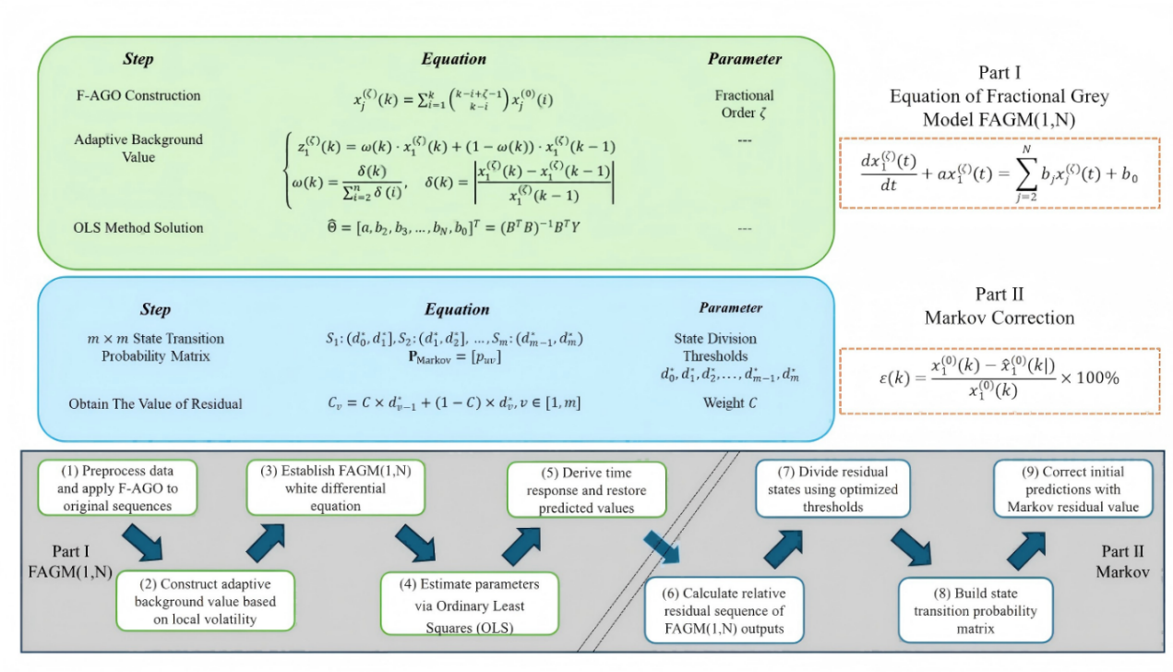
FIGURE 1 Detailed process of FAGM(1,N)-Markov.

3.4 Parameter Optimization of Gravitational Search Algorithm (GSA)
The accuracy of the FAGM(1,N) model is highly dependent on the fractional order $ζ$. In Section 3.3, the correction amount of the residual depends on the setting of the key parameter $C$, and the state interval division of Markov correction also affects the result. Traditional methods set these parameters subjectively, leading to limited generalization ability of the model. This paper proposes for the first time to use the Gravitational Search Algorithm (GSA) for global collaborative optimization of these three key parameters.

3.4.1 Optimization Parameter Encoding and Fitness Function
The parameter vector to be optimized is defined as.
$$P=[ζ,C,d_{1},d_{2},…,d_{m-1}]$$ | (19)
Each parameter corresponds to a range. $ζ∈(0,2]$: fractional accumulation order. $C∈[0,1]$: weight adjustment factor, which controls whether the error correction value is more dependent on the upper limit or lower limit of the interval (the closer $C$ is to 1, the more important the upper limit is; the closer it is to 0, the more important the lower limit is). $d_{1}<d_{2}<…<d_{m-1}$: $m-1$ interval boundary thresholds for dividing Markov states (assuming that $m$ states are divided).
Each particle represents a candidate parameter combination $P_{i}$, among which the optimal parameter combination is ${P_{i}}^{best}$. The optimization goal is to minimize the comprehensive prediction error on the training set. This paper selects the Root Mean Square Error (RMSE) as the fitness function, which is more sensitive to large errors and can drive the model to find a more stable solution.
$$Fitness(P_{i})={RMSE}_{train}=\sqrt[​]{\frac{1}{n_{train}}\sum_{k=1}^{n_{train}}{{\left(x_{1}^{(0)}(k)-{​​​x}_{1}^{(0)}(k|P_{i})\right)}^{2}}}$$ | (20)
${​​​x}_{1}^{(0)}(k|P_{i})$ represents the fitting value of the $k$-th sample by the FAGM(1,N) model when using the parameter setting $P_{i}$.

3.4.2 IGSA Optimization Process
(1) GSA Algorithm
GSA (Gravitational Search Algorithm) is a heuristic optimization algorithm that simulates the law of universal gravitation in physics for search (Avalos 2021; Ruan et al. 2026; You and Chen 2025). In GSA, the solution to the optimization problem is regarded as a group of particles moving in space. Assuming that there are $N$ particles in a $D$-dimensional search space, the position of the $i$-th particle in the $D$-dimensional search space is $X_{i}=[x_{i}^{1},⋯,x_{i}^{d},⋯,x_{i}^{D}]$, where $i=1,2,⋯,N$, and $x_{i}^{d}$ represents the position of the $i$-th particle in the $d$-th dimension, giving the force formula of particle $i$ subjected to particle $j$ in the $d$-th dimension at time $t$, which is expressed as follows. Figure 2 shows GSA schematic diagram.
$$F_{ij}^{d}(t)=G(t)\frac{M_{i}(t)*M_{j}(t)}{R_{ij}(t)+ε}\left(x_{j}^{d}(t)-x_{i}^{d}(t)\right)$$ | (21)
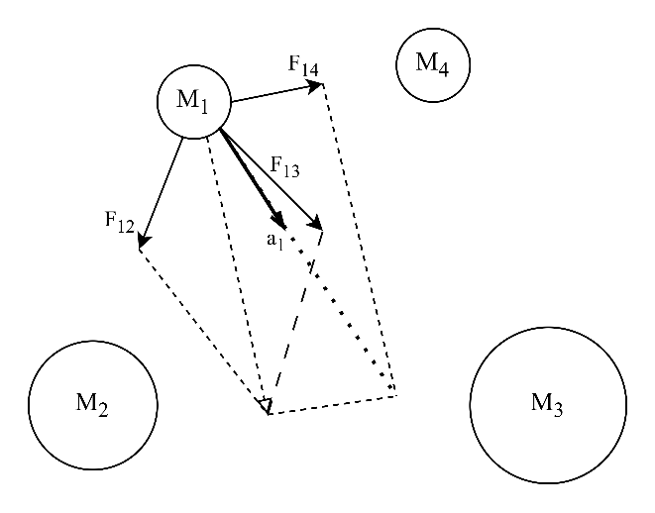
FIGURE 2 GSA schematic diagram.
In formula above, $M_{i}(t)$ and $M_{j}(t)$ represent the inertial masses of particle $i$ and particle $j$ at time $t$ respectively. $G(t)$ represents the gravitational constant at time $t$, $ε$ is a very small constant, and $R_{ij}(t)$ represents the Euclidean distance between particle $i$ and particle $j$ at time $t$.
$$R_{ij}(t)={∥X_{i}(t),X_{j}(t)∥}_{2}$$ | (22)
To increase randomness, the resultant force of particle $i$ in the $d$-th dimension is defined as $F_{i}^{d}(t)$, which is expressed as follows.
$$F_{i}^{d}(t)=\sum_{j=1,j≠i}^{N}{r}and(0,1)_{j}F_{ij}^{d}(t)$$ | (23)
$F_{ij}^{d}(t)$ is the force between particle $i$ and particle $j$ in $d$-th dimension at time $t$. According to Newton’s second law, the acceleration of particle $i$ in the $d$-th dimension at time $t$ is defined as $a_{i}^{d}(t)$, which is expressed as follows.
$$a_{i}^{d}(t)=\frac{F_{i}^{d}(t)}{M_{i}(t)}$$ | (24)
Using the fitness value, the inertial mass $M_{i}(t)$ of particle $i$ is updated according to formulas below.
$$m_{i}(t)=\frac{fit_{i}(t)-worst(t)}{best(t)-worst(t)}$$ | (25)
$$M_{i}(t)=\frac{m_{i}(t)}{\sum_{j=1}^{N}{m_{j}}(t)}$$ | (26)
For the problem of minimizing the objective function, the definitions of $best(t)$ and $worst(t)$ are:
$$best(t)=min_{i∈​1,2,⋯,N​}fit_{i}(t)$$ | (27)
$$worst(t)=max_{i∈​1,2,⋯,N​}fit_{i}(t)$$ | (28)
For the problem of maximizing the objective function, the definitions of $best(t)$ and $worst(t)$ are:
$$best(t)=max_{i∈​1,2,⋯,N​}fit_{i}(t)$$ | (29)
$$worst(t)=min_{i∈​1,2,⋯,N​}fit_{i}(t)$$ | (30)
Where $fit_{i}(t)$ is the fitness value of particle $i$ at time $t$. In GSA, in each iteration, particle $i$ updates its velocity and position according to the following formulas.
$$v_{i}^{d}(t+1)=rand(0,1)_{i}*v_{i}^{d}(t)+a_{i}^{d}(t)$$ | (31)
$$x_{i}^{d}(t+1)=x_{i}^{d}(t)+v_{i}^{d}(t+1)$$ | (32)
The analysis of GSA shows that due to the gravitational effect between particles, particles with small inertial mass move with a long step length, which is convenient for searching the global optimum and reflects the search performance of GSA. Particles with large inertial mass move with a short step length, which is convenient for maintaining and developing the current optimal solution and reflects the development performance of GSA. However, it has some issues that the convergence speed of GSA is faster than that of other optimization algorithms, and it is easy to fall into premature convergence and local optimum.
(2) Algorithm Improvement: Dynamic Adjustment of Gravitational Constant $G$
In GSA, parameter control is crucial for solving specific problems, namely the gravitational constant $G$, population size $N$, number of iterations $T$ and attenuation rate $α$. The gravitational constant $G$ directly affects the resultant force and acceleration of particles. It plays an important role in whether particles in GSA can jump out of local optimum and improve the accuracy of the optimal solution. The reasonable setting of the gravitational constant can ensure the search performance of GSA. The expression of the gravitational constant $G$ is:
$$G(t)=G_{0}e^{-α\frac{t}{T}}$$ | (33)
$G_{0}$ is the initial value of the gravitational constant, $α$ is the quantity describing the attenuation rate, $T$ is the maximum number of iterations, and $t$ is the current number of iterations. According to current study (Xie Wei; Ding Qiang; Jiang Aipeng; Jiang Zhixu, n.d.), GSA has the best performance when $G_{0}=100,α=20$, which is the variable setting in our study for IGSA.
The value of the gravitational constant $G(t)$ decreases rapidly with the increase of $t$ in the early stage of iteration, and finally tends to be stable when $t$ is large enough, that is, $G(t)$ decreases rapidly in the early stage of iteration and slowly in the later stage of iteration. The gravitational constant $G$ has an important influence on the step length of particle movement. Relatively speaking, the larger $G$ is, the longer the step length is. On the contrary, the smaller $G$ is, the shorter the step length is. This paper introduces the dynamic adjustment strategy of gravitational constant $G(t)$ to design the gravitational constant.
$$G^{'}(t)=G_{0}e^{-α\frac{t}{T}*\left(ω_{1}+ω_{2}*\frac{t}{T}\right)}$$ | (34)
where $ω_{1}$ and $ω_{2}$ are weights, usually taking $ω_{1}=1.5$ and $ω_{2}=1$. When $G^{'}(t)<G(t)$, $G(t)$ moves with large steps in the early stage of iteration and slowly in the later stage of iteration. In its early stage of iteration, it is conducive to controlling the step length to prevent particles from skipping points with high fitness values, increasing the diversity of particles while maintaining good search ability. In the later stage of iteration, it is conducive to the refined optimization of particles and enhances the development performance of particles. The dynamic strategy of the gravitational constant $G(t)$ ensures the adjustment of the particle convergence speed, and improves the optimization accuracy. Here is the algorithm computational process of IGSA.
ALGORITHM 1 Computational process for Improved GSA.
Population Size = 25, Maximum Iterations = 80, Initial Gravitational Constant (G0) = 100, attenuation rate (α) = 20.
Set weights for gravitational constant adjustment: ω1 = 1.5, ω2 = 1.
Define ranges: ζ ∈ (0, 2], C ∈ [0, 1], Markov state thresholds d₁ < d₂ <... < dₘ₋₁ within valid residual ranges.
Randomly generate initial population: each particle represents a parameter combination (ζ, C, d₁,..., dₘ₋₁).
while current iteration (t) < maximum iterations:
For each particle,
calculate the training set’s RMSE as fitness.
Compute G'(t) based on iteration progress: combine G0, α, ω1, ω2, t/T and local optimization
Find the min and max fitness values in the current population. # Determine Optimal and Worst Fitness
For each particle:
Calculate its relative inertial mass, normalize mass across the population.
For each particle:
sum the gravitational forces from all other particles, compute acceleration by inertial mass.
Update particle velocity using previous velocity and current acceleration (add random factor for diversity).
Update particle position based on new velocity to get new parameter combinations.
If any parameter exceeds its predefined range (e.g., ζ > 2 or C < 0),
adjust it back to the nearest valid value.
t = t + 1 # Increment Iteration
After iterations end, select the particle with the smallest fitness (best RMSE)

3.5 Model Performance Evaluation Metrics
To comprehensively evaluate the prediction performance of the proposed GSA-FAGM(1,N)-Markov model, the following three widely used statistical indicators are adopted and calculated on the test set.
(1) Mean Absolute Percentage Error, MAPE
$$MAPE=\frac{1}{n_{test}}\sum_{k=1}^{n_{test}}{\frac{\left|x_{1}^{(0)}(k)-{\hat{x}}_{1}^{(0)}(k)\right|}{x_{1}^{(0)}(k)}}×100\%$$ | (35)
(2) Root Mean Square Error, RMSE
$$RMSE=\sqrt[​]{MSE}\sqrt[​]{\frac{1}{n_{test}}\sum_{k=1}^{n_{test}}{{\left(x_{1}^{(0)}(k)-{​​​x}_{1}^{(0)}(k)\right)}^{2}}}$$ | (36)
(3) Mean Absolute Error, MAE
$$MAE=\frac{1}{n_{test}}\sum_{k=1}^{n_{test}}{\left|x_{1}^{(0)}(k)-{​​​x}_{1}^{(0)}(k)\right|}$$ | (37)
$n_{test}$ is the number of samples in the test set, and $x_{1}^{(0)}(k)$ and ${​​​x}_{1}^{(0)}(k)$ are the actual observed value and the predicted value of the model for the $k$-th sample respectively. MSE and RMSE emphasize the punishment of large errors, MAE gives the average absolute deviation, while MAPE provides a relative error measurement independent of the data scale, which is convenient for comparison across different sequences. An excellent prediction model should have low RMSE (MSE), MAE and MAPE values at the same time.

4 Case Study
Although numerous studies have focused on forecasting in industries such as industry and economics, research on forecasting in the agricultural sector is relatively scarce. To test our proposed method, this study selects 8-year data of Chinese agricultural products from 2013 to 2020 and forecasts the logistics transportation volume of frozen agricultural products.
Meanwhile, we consider the relevant influencing factors (detailed information is listed in the TABLE 1 below) and use the method described in Section 3 to forecast the next 4 years. To verify the effectiveness and accuracy of our method, we also adopt other approaches to predict the same time series data and compare the results. This section is organized as follows:
(1) FAGM(1,1) model is used to predict each relevant factor. As a method for single time series forecasting, it is essentially similar to FAGM(1,N). If the data passes the ratio test (Section 3.1), the relevant factors $X_{j}(j=1,2,3,4,5)$ are predicted separately. Data from 2013 to 2020 are used to forecast data from 2021 to 2024.
(2) Based on the existing data and the predicted data of relevant factors, the FAGM(1,N) model is constructed. The optimal parameter setting ${P_{i}}^{best}$ is obtained through GSA, and the optimal prediction results are derived using this parameter setting.
(3) To explore the improvement of prediction accuracy brought by Markov correction, fractional-order GM, and the adaptability of the adjacent mean sequence $z_{1}^{(ζ)}(k)$ calculation, GSA is uniformly used for parameter search and optimization.
Five types of GM(1,N) models are adopted for performance comparison. The TABLE below presents the research dataset. The relevant variables in our study include: (1) Primary Industry Added Value; (2) Tertiary Industry Employees; (3) Agricultural Product Market Transaction Volume; (4) National Logistics Total Cost; (5) Agricultural Product Price Index. In FAGM(1,N), the Frozen Agricultural Products Logistics Transportation is predicted based on these five relevant variables. The data in this article is derived from existing studies (Peng Xiu-xiu, n.d.).
Table 1 Dataset for forecasting.
Year \  Variable | Frozen Agricultural Products Logistics Transportation (100 million tons) | Primary Industry Added Value  (100 million yuan) | Tertiary Industry Employees  (10000 people) | Agricultural Product Market Transaction Volume  (100 million yuan) | National Logistics Total Cost  (100 million yuan) | Agricultural Product Price Index
Label | $$S$$ | $$X_{1}$$ | $$X_{2}$$ | $$X_{3}$$ | $$X_{4}$$ | $$X_{5}$$
2013 | 0.77 | 53028.1 | 76977 | 14584.08 | 102000 | 115
2014 | 0.92 | 55626.3 | 77253 | 15507.83 | 106000 | 114.5
2015 | 1.05 | 57774.6 | 77451 | 16483.83 | 108000 | 99.1
2016 | 1.25 | 60139.2 | 77603 | 17466.52 | 111000 | 96.5
2017 | 1.48 | 62099.5 | 77640 | 19346.68 | 121000 | 103.4
2018 | 1.89 | 64745.2 | 77586 | 18327.26 | 133000 | 101.7
2019 | 2.33 | 70473.6 | 77471 | 19785.31 | 146000 | 99.8
2020 | 2.87 | 77754.1 | 75064 | 18548.74 | 149000 | 103.2

4.1 Prediction of Relevant Variables Using GSA-Markov-FAGM(1,1)
To construct the subsequent FAGM(1,N) multivariate prediction model, it is necessary to first obtain the future trend data of core influencing factors. This study selects 5 key relevant variables, denoted as $X_{1}$-$X_{5}$. Within 8-year data from 2013 to 2020 as the training set, FAGM(1,1) model optimized by GSA is used to predict data from 2021 to 2024, and Markov residual correction is introduced to improve prediction accuracy.
GSA is used for global optimization of the core parameters of FAGM(1,1). After introducing Markov correction, fractional order $ζ$ and the weight adjustment factor $C$ are optimized synchronously. The Root Mean Square Error (RMSE) is adopted as the fitness function to suppress the impact of large errors. GSA parameter settings are population size = 25, maximum number of iterations = 80, initial gravitational constant $G_{0}=100$, attenuation coefficient $α=20$, and dynamic adjustment of the gravitational constant is used to avoid premature convergence. Figure 3 displays the prediction data, dotted lines in the figure divide the actual data from the predicted data.
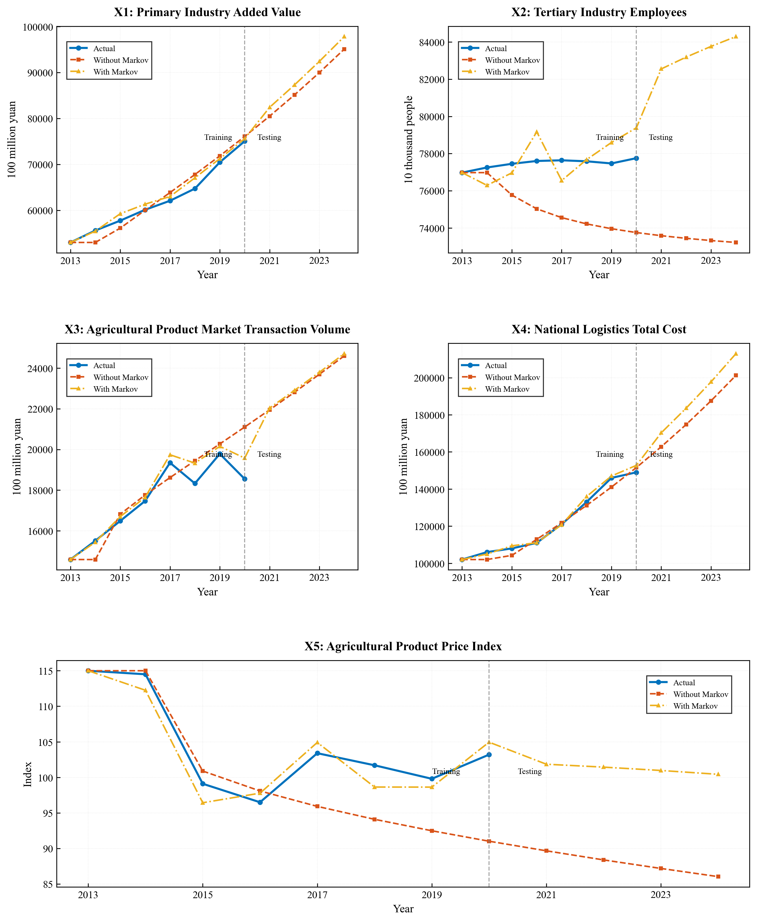
FIGURE 3 FAGM(1,N)-Markov-IGSA results for variables $X_{1}$-$X_{5}$.
TABLE 2 Forecasting results for $X_{1}$-$X_{5}$.
Year | $$X_{1}$$ |  |  | $$X_{2}$$ |  |  | $$X_{3}$$ |  |  | $$X_{4}$$ |  |  | $$X_{5}$$
Year | Actual | Fitted  (without Markov) | Fitted (with Markov) | Actual | Fitted (without Markov) | Fitted (with Markov) | Actual | Fitted (without Markov) | Fitted (with Markov) | Actual | Fitted (without Markov) | Fitted (with Markov) | Actual | Fitted (without Markov) | Fitted (with Markov)
2013 | 53028.10 | 53028.10 | 53028.10 | 76977.00 | 76977.00 | 76977 | 14584.08 | 14584.08 | 14584.08 | 102000.00 | 102000.00 | 102000.00 | 115.00 | 115.00 | 115.00
2014 | 55626.30 | 53028.1 | 55491.69 | 77253.00 | 76977.00 | 76292.34 | 15507.83 | 14584.08 | 15441.07 | 106000.00 | 102000.00 | 104958.9 | 114.50 | 115.00 | 112.25
2015 | 57774.60 | 56145.94 | 59275.14 | 77451.00 | 75769.90 | 76965.51 | 16483.83 | 16817.02 | 16697.29 | 108000.00 | 104252.71 | 109410.32 | 99.10 | 100.89 | 96.43
2016 | 60139.20 | 60034.90 | 61357.580 | 77603.00 | 75028.29 | 79170.570 | 17466.52 | 17759.126 | 17641.120 | 111000.00 | 112895.26 | 111044.48 | 96.50 | 98.090 | 97.78
2017 | 62099.50 | 63881.26 | 63022.92 | 77640.00 | 74557.11 | 76552.77 | 19346.68 | 18616.03 | 19740.21 | 121000.00 | 121803.86 | 120744.82 | 103.40 | 95.92 | 104.91
2018 | 64745.20 | 67804.83 | 67081.69 | 77586.00 | 74219.05 | 77675.27 | 18327.26 | 19446.33 | 19328.19 | 133000.00 | 131154.65 | 135958.03 | 101.70 | 94.10 | 98.64
2019 | 70473.60 | 71861.61 | 71263.40 | 77471.00 | 73960.14 | 78597.78 | 19785.31 | 20272.14 | 20153.14 | 146000.00 | 141052.72 | 147010.53 | 99.80 | 92.49 | 98.63
2020 | 75064.00 | 76085.43 | 75608.34 | 77754.10 | 73753.66 | 79385.36 | 18548.74 | 21104.61 | 19575.63 | 149000.00 | 151575.98 | 152759.08 | 103.20 | 91.02 | 104.95
2021 | - | 80500.83 | 82413.38 | - | 73584.44 | 82554.27 | - | 21950.38 | 22038.18 | - | 162791.92 | 170309.19 | - | 89.67 | 101.85
2022 | - | 85128.01 | 87299.33 | - | 73443.06 | 83190.04 | - | 22813.94 | 22908.44 | - | 174764.55 | 183577.63 | - | 88.39 | 101.44
2023 | - | 89985.10 | 92426.95 | - | 73323.24 | 83766.41 | - | 23698.58 | 23799.84 | - | 187557.79 | 197769.08 | - | 87.19 | 100.97
2024 | - | 95089.30 | 97815.73 | - | 73220.64 | 84295.01 | - | 24606.91 | 24715.05 | - | 201237.23 | 212964.40 | - | 86.04 | 100.43

Table 3 lists the optimal parameters and performance improvement indicators of each variable. It can be seen that the optimal fractional order $ζ$ corresponding to Markov correction is mostly concentrated between 0.94 and 0.96, close to the integer order but still retaining the emphasis of the fractional order on recent information. The weight adjustment factor $C$ ranges from 0.0065 to 0.3428, indicating different emphases on the upper and lower limits, which can improve prediction accuracy. In the results, $X_{1}$ ($C=0.0065$) is more dependent on the lower limit of the interval, while $X_{5}$ ($C=0.3428$) has a relatively balanced weight on the upper and lower limits.
TABLE 3 Performance comparison between Markov-FAGM(1,1) & FAGM(1,1).
Performance\Variables | $$X_{1}$$ | $$X_{2}$$ | $$X_{3}$$ | $$X_{4}$$ | $$X_{5}$$
Best $ζ$（without Markov） | 0.9685 | 1.0208 | 0.9601 | 0.9734 | 1.0408
Best $ζ$（with Markov） | 0.9591 | 0.9445 | 0.9593 | 0.953 | 0.9466
Best $C$（with Markov） | 0.0065 | 0.2574 | 0.0121 | 0.2336 | 0.3428
RMSE（without Markov） | 1886.79 | 2895.85 | 1171.42 | 3134.98 | 6.78
RMSE（with Markov） | 1252.78 | 1117.17 | 588.83 | 1965.48 | 2.07
RMSE Improvement（%） | 33.6 | 61.42 | 49.73 | 37.31 | 69.52
MAPE（without Markov）（%） | 2.66 | 3.4 | 5.11 | 2.3 | 5.39
MAPE（with Markov）（%） | 1.69 | 1.28 | 2.52 | 1.14 | 1.9
MAPE Improvement（%） | 36.48 | 62.41 | 50.76 | 50.51 | 64.7
Note: RMSE & MAE the lower the better.
Figure 4 and Figure 5 present the comparison of MAE and RMSE results, proving a conclusion that Markov can enhance the prediction accuracy. Among the five related factor predictions, the prediction method with Markov correction has significantly higher performance compared to the method without error correction.
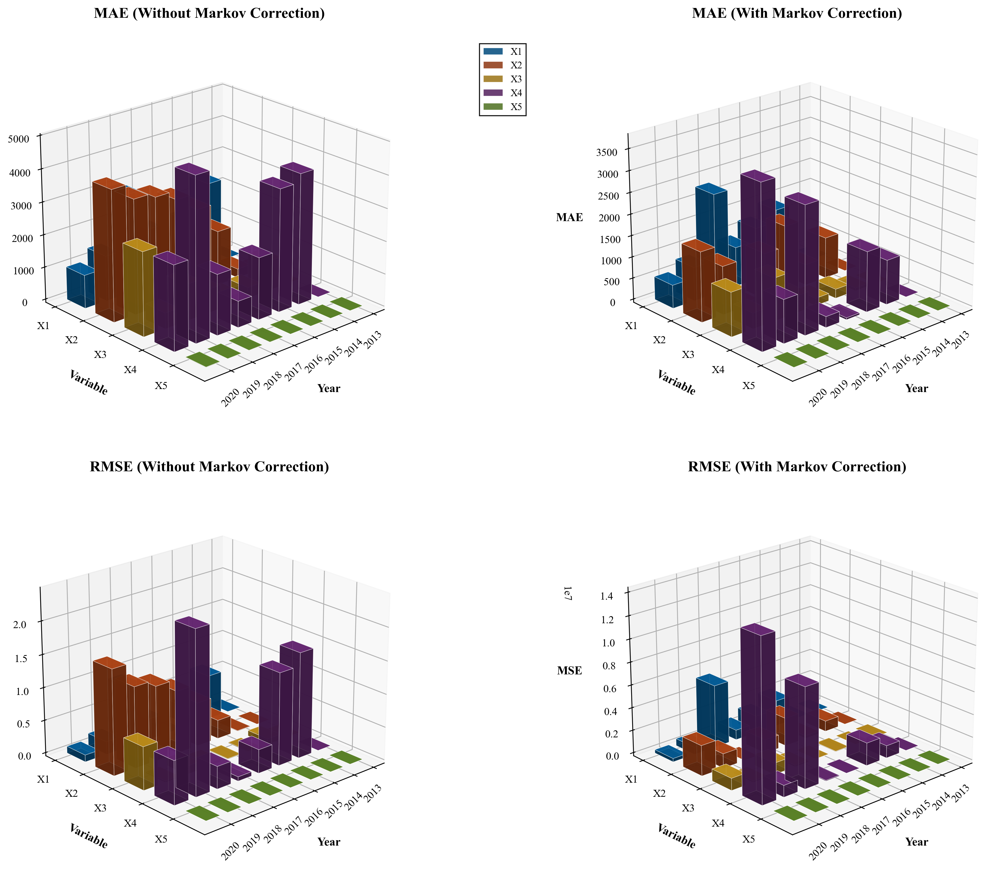
FIGURE 4 MAE Comparison demonstrates the decrease of residual under Markov method.
FIGURE 5 RMSE Comparison demonstrates the decrease of residual under Markov method.
MAPE is also one of the important indicators for measuring the accuracy of predictions. We compare the MAPE values of the prediction methods. Figure 6 presents the heat map and the degree of improvement in MAPE.
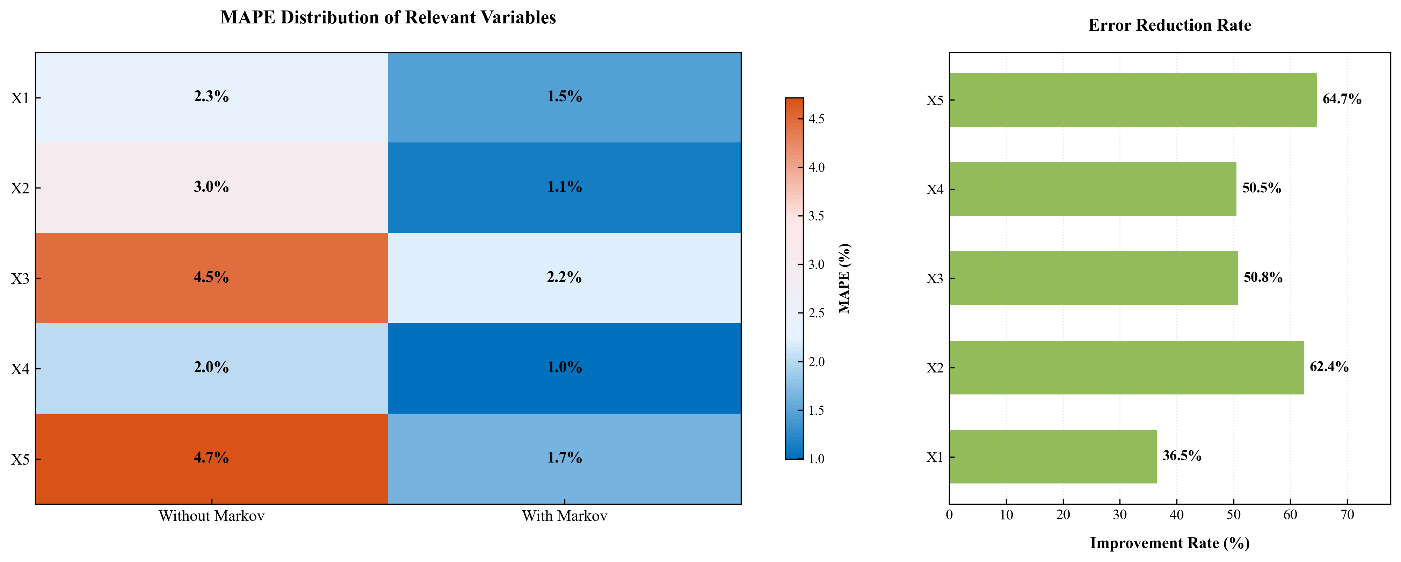
FIGURE 6 MAPE heatmap Comparison.

4.2 Prediction Results and Performance Comparison
Based on the data obtained from FAGM(1,1), next we will predict the key target: Frozen Agricultural Products Logistics Transportation ($S$). In FAGM(1,N), the prediction sequence $S$ needs to combine the relevant data of $X_{1}-X_{5}$ from 2013 to 2024, which is a crucial step and also the reason why we first perform single sequence prediction.
In Section 4.1, Markov-FAGM(1,1) optimized by GSA has completed the prediction of data from 2021 to 2024 for five key influencing factors, providing complete independent variable time series data for constructing the multivariate prediction model. This section takes the actual data of frozen agricultural products logistics transportation volume ($S$) from 2013 to 2020 as the dependent variable training set, combines the historical actual data and future predicted data of the above independent variables, constructs the FAGM(1,N) multivariate prediction framework, and further introduces GSA parameter optimization and Markov residual correction to finally achieve accurate prediction of frozen agricultural products logistics transportation volume from 2021 to 2024.
To systematically verify the effectiveness of each core improvement module: fractional-order accumulation, adaptive background value, GSA parameter optimization, Markov residual correction in the proposed model, so five comparison models are set up. The differences in core characteristics of each model are shown in the Table 4.
TABLE 4 Comparison of five selected forecasting methods.
Model ID | 1 | 2 | 3 | 4 | 5
Whether Markov is included | √ | √ | - | √ | -
Whether GM is Fractional | √ | √ | √ | - | -
Whether the model have adaptability | √ | - | √ | √ | -
Model Name | FAGM(1,N)-  GSA-  Markov | FGM(1,N)  -Markov | FAGM(1,N)  -GSA | AGM(1,N)-  Markov | GM(1,N)
The parameter optimization of all models adopts the same GSA settings as in Section 4.1 and RMSE is uniformly selected as the fitness function to ensure the fairness of comparison. Based on the calculation results of the above 5 models, the predicted values of frozen agricultural products logistics transportation volume ($S$) from 2021 to 2024 are first presented in Table 5.
TABLE 5 Prediction results of five different methods.
Year\  Model | FAGM(1,N)-  GSA-  Markov | FGM(1,N)-  Traditional Background  -Markov | FAGM(1,N)-  GSA  (No Markov) | GM(1,N)-  Markov  (Order=1) | Standard GM(1,N) (Traditional, No Markov)
2021 | 3.3945 | 3.1408 | 2.9431 | 6.9245 | 6.3588
2022 | 4.1513 | 3.8321 | 3.5909 | 8.6464 | 7.9400
2023 | 5.104 | 4.708 | 4.412 | 10.6893 | 9.8152
2024 | 6.2859 | 5.8031 | 5.4393 | 13.0971 | 12.0256
From the perspective of the trend of predicted values, the prediction results of Model 1 proposed in this study show a steady growth trend. The predicted values from 2021 to 2024 are 339, 415, 510, and 629 million tons respectively, with an annual growth rate in a reasonable range of approximately 22%-23%.
Figure 7 intuitively shows the fitting and prediction effects of the proposed model. The prediction trajectories of all comparison models are summarized, clearly showing the differences among each model. Prediction curve of Model 1 is always in a reasonable growth range, while the curves of Model 4 and Model 5 rise steeply, which are obviously divorced from reality; the curves of Model 2 and Model 3 grow gently but fail to fully capture the industry growth potential, resulting in low predicted values.
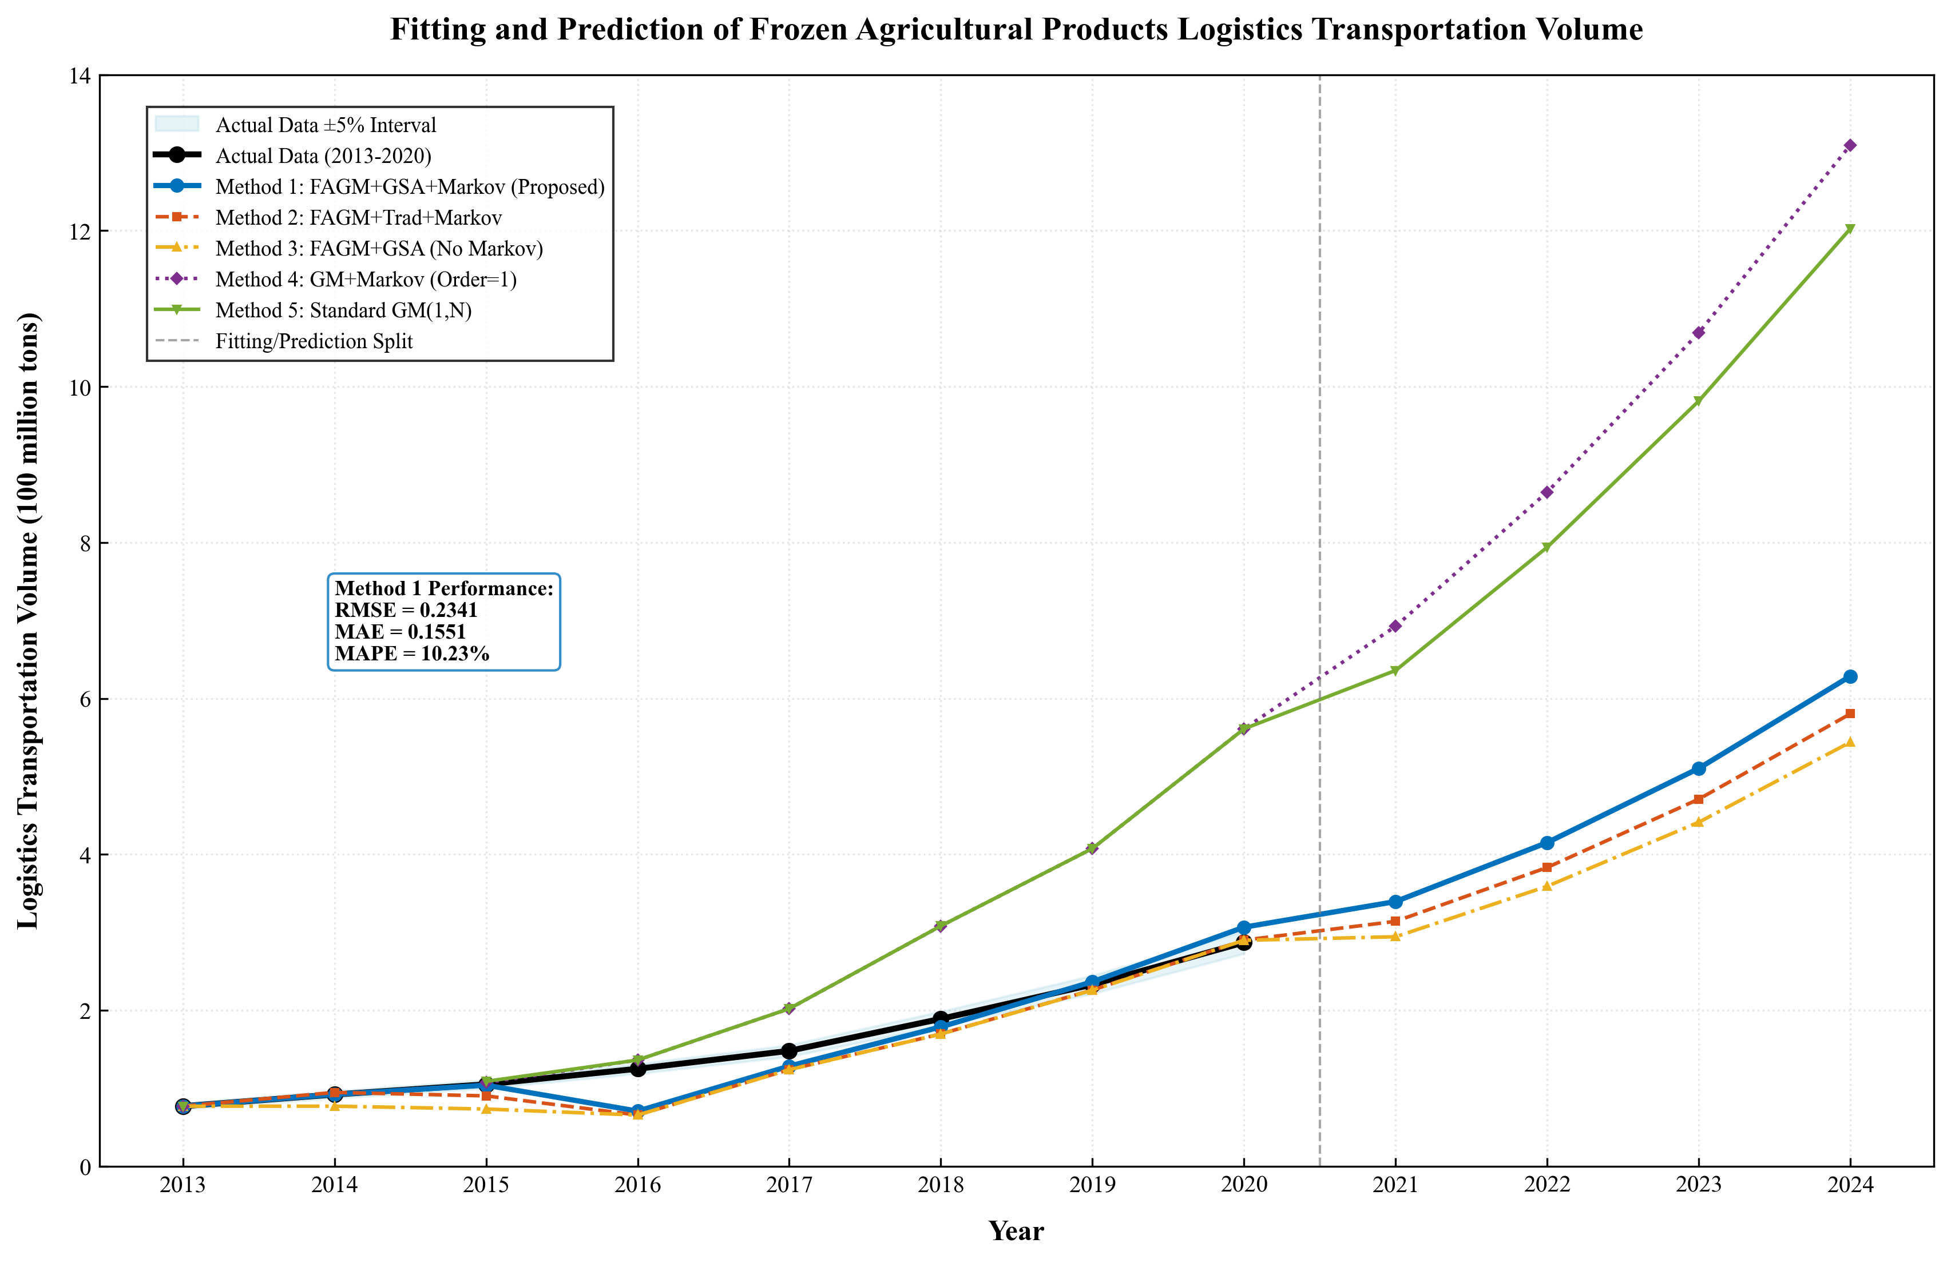
FIGURE 7 Prediction results of five methods.
Compared with other models, the predicted values of Model 4 and Model 5 are significantly higher, reaching 1.31 billion tons and 1.203 billion tons respectively in 2024, which are far beyond the reasonable growth range. This is mainly because the traditional first-order grey model has limited fitting ability for nonlinear sequences and does not consider the correction of random fluctuations of residuals, leading to excessive growth deviation in prediction results. Although the predicted values of Model 2 and Model 3 are better than those of the first-order GM model, they are still lower than those of Model 1, indicating that the fixed weight of the traditional background value cannot fully adapt to the data fluctuation characteristics, and the lack of Markov residual correction makes it difficult to offset the prediction errors caused by random factors.
To quantitatively evaluate the accuracy of each model, RMSE and MAE defined in Section 3.5 are used as performance evaluation indicators, and the calculation results are shown in Figure 8 and Figure 9. From the perspective of performance indicators, Model 1 proposed in this study performs the best, with $RMSE = 0.2341$ and $MAE = 0.1551$, which are significantly lower than those of other comparison models. Table 6 below shows the RMSE, MAE and MAPE results.
Table 6 Performance comparison of five different methods.
Method ID | Method | RMSE | MAE | MAPE (%)
1 | FAGM(1,N)-GSA-Markov (Adaptive) | 0.2341 | 0.1551 | 10.2340
2 | FAGM(1,N)-Traditional Background-Markov | 0.2607 | 0.1859 | 13.5672
3 | FAGM(1,N)-GSA (No Markov) | 0.2873 | 0.2281 | 17.8065
4 | GM(1,N)-Markov | 1.3692 | 1.0387 | 54.4286
5 | Standard GM(1,N) | 1.3693 | 1.04104 | 54.6477
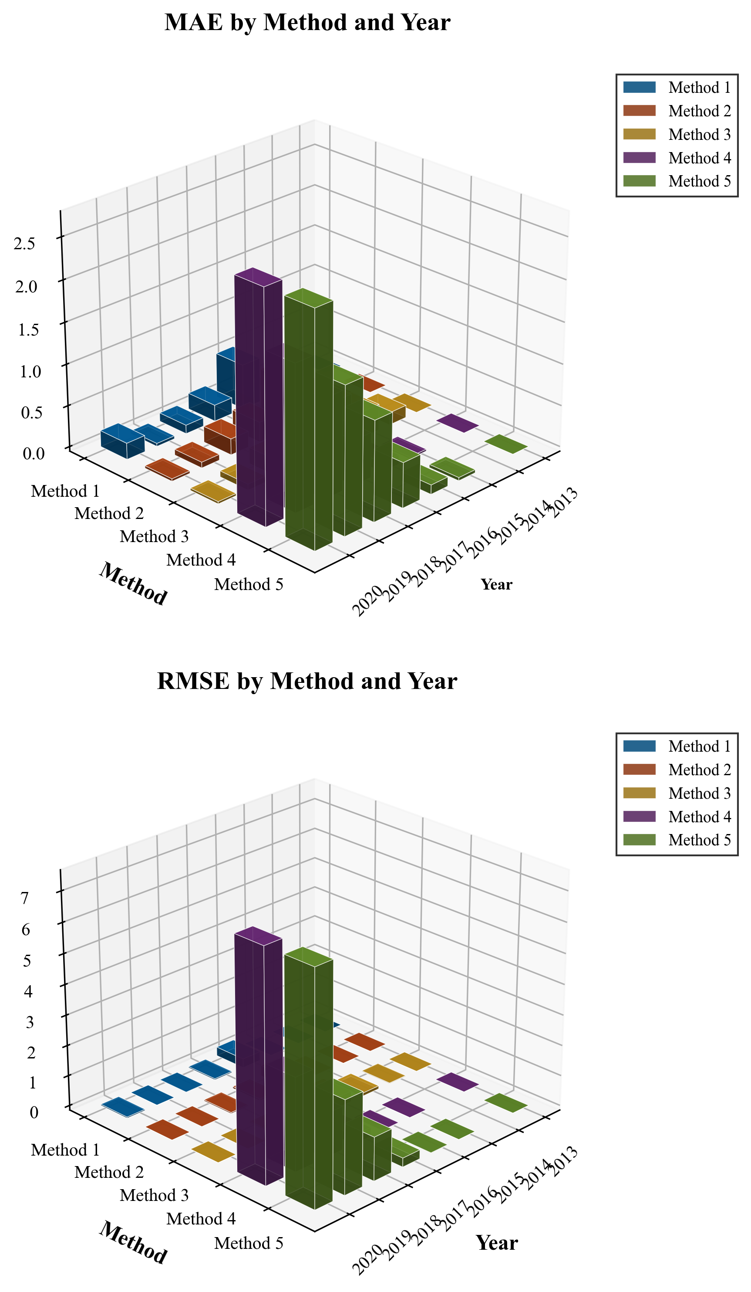
FIGURE 8 RMSE of five forecasting methods.
FIGURE 9 MAE of five forecasting methods.
Comparing Model 1 with Model 4, the RMSE and MAE of Model 4 are much higher than those of Model 1, indicating that F-AGO can more flexibly adjust the weight of historical data, highlight the leading role of recent information, and effectively improve the fitting accuracy of nonlinear sequences. Comparing Model 1 with Model 2, the RMSE and MAE of Model 2 are higher than those of Model 1, indicating that the adaptive weight based on local data volatility can make the background value more consistent with the actual change trajectory of the sequence, and the construction of the adaptive adjacent sequence improves the prediction accuracy. Comparing Model 1 with Model 3, the prediction accuracy of Model 3 is significantly lower than that of Model 1, indicating that the Markov chain can effectively capture the random fluctuation characteristics of the residual sequence and correct the initial predicted value through the state transition probability matrix, which has a great impact on the prediction accuracy.
In addition, all models adopting GSA optimization, including Model 1, Model 2, Model 3, are superior to those not adopting global optimization (Model 4, Model 5), which verifies optimization ability of GSA for key parameters such as fractional order $ζ$, weight adjustment factor $C$, and Markov state division thresholds. Traditional problem of insufficient generalization ability caused by subjective parameter setting are avoided.
As a traditional benchmark model, Model 5, standard GM(1,N), has the largest RMSE and MAE, which further illustrates the accuracy improvement achieved by the proposed model through multi-module improvement, and verifies the applicability of the hybrid model in the prediction of frozen agricultural products logistics transportation volume with small samples, nonlinearity, and multiple variables.
In addition to MSE and MAE, MAPE is also an important measurement indicator. Compared with other schemes, the FAGM(1,N)-Markov-IGSA in this paper has certain advantages in MAPE, as shown in Figure 10.
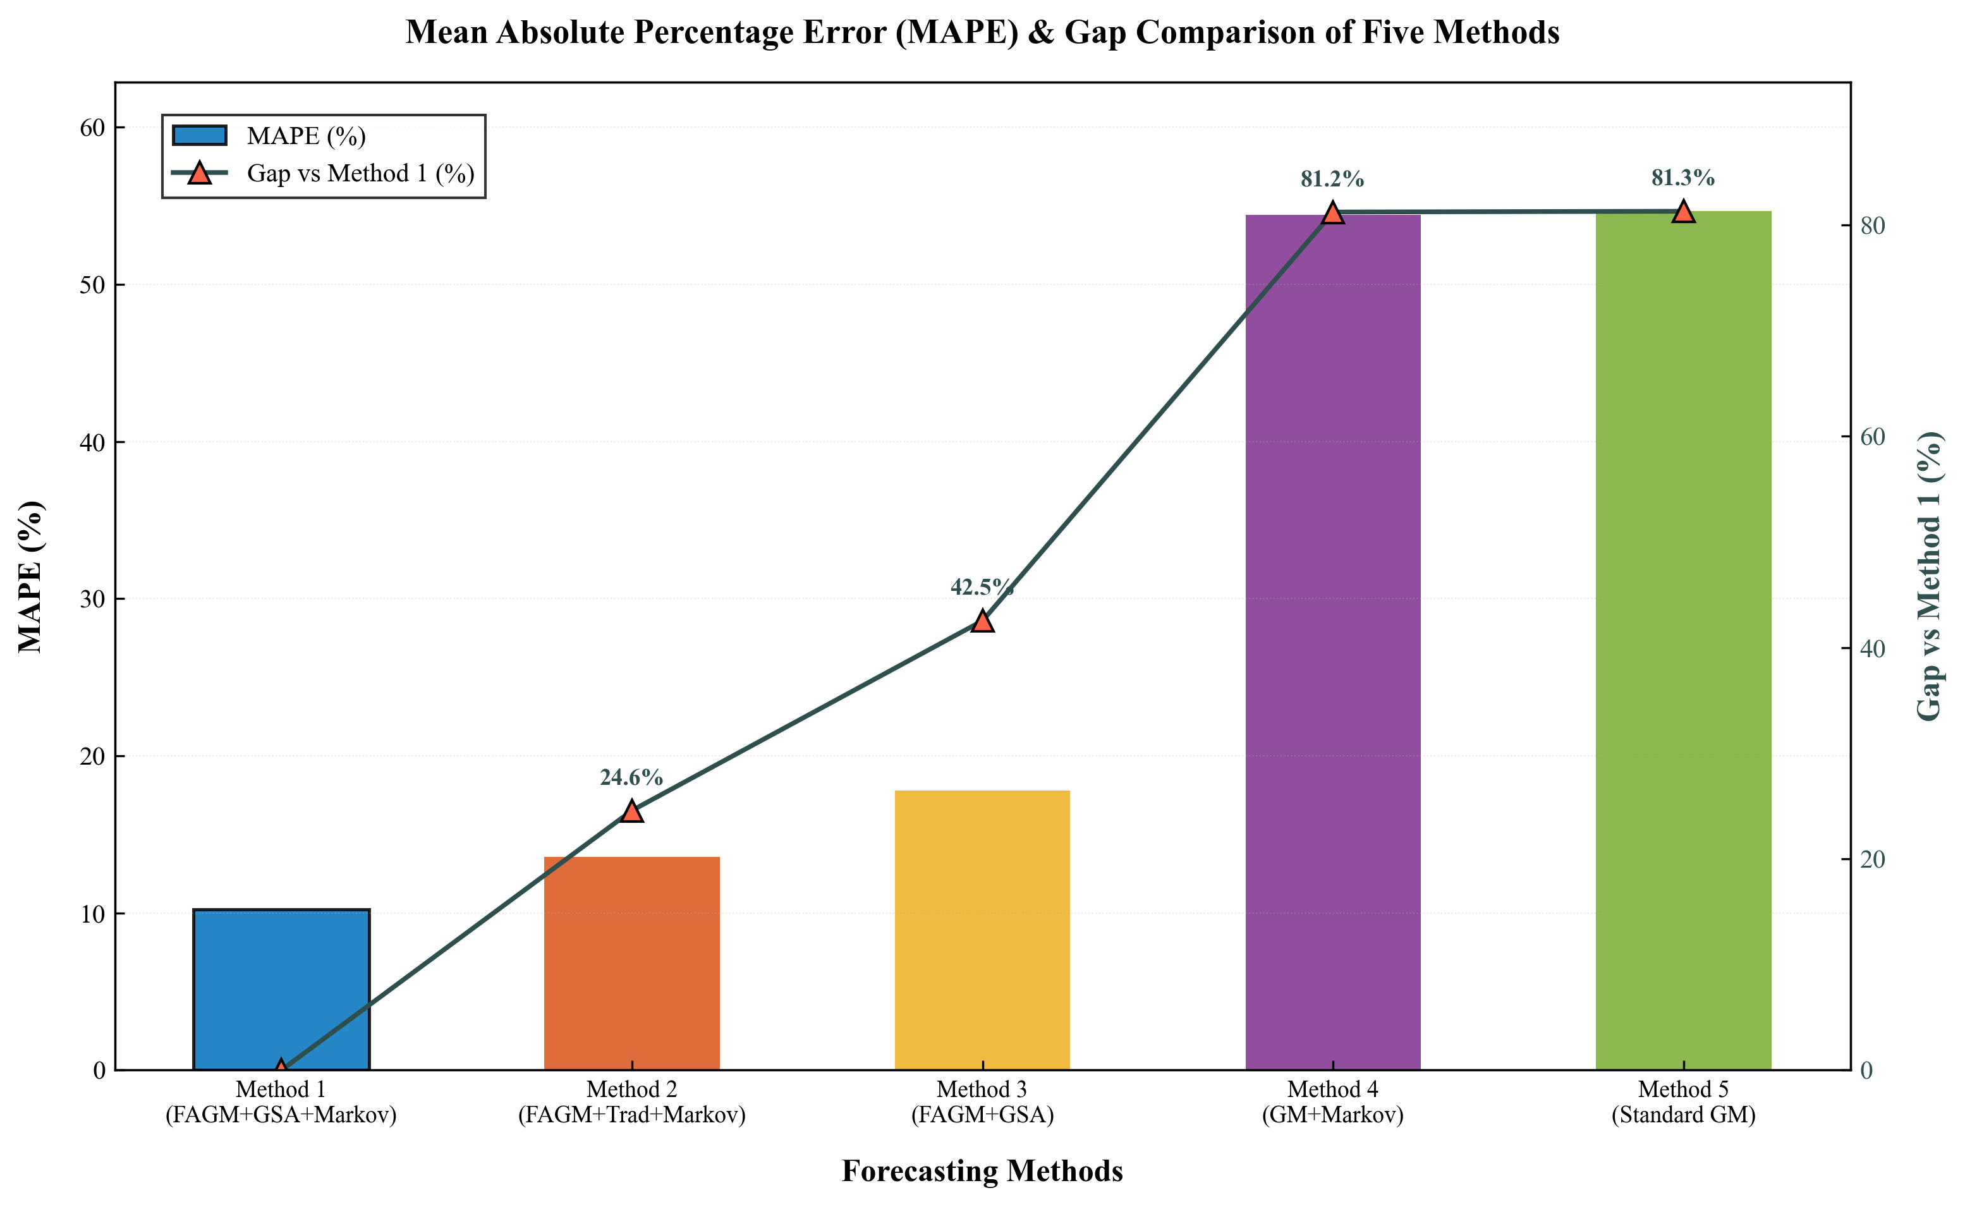
FIGURE 10 Comparison of Prediction Results Among Five Methods.
Our prediction results are obtained by combining the actual situation of China’s agricultural development and the cold chain logistics industry, using Model 1 (FAGM(1,N)-GSA-Markov) to predict the next 4 years. Compared with other schemes, this method has improved accuracy on the real known data sequence. Among them, Markov correction plays an important role, and the introduction of GSA for parameter search avoids the subjectivity of parameter setting, further improving the accuracy.

5 Conclusion
Our study focuses on addressing the prediction challenges of frozen agricultural products logistics transportation volume under small-sample, nonlinear, and multi-variable conditions with IGSA-Markov-FAGM(1,N) hybrid model, and we verify its effectiveness through empirical analysis.
The core contributions and characteristics of this study are as follows:
(1) It integrates multiple optimization modules synergistically, combining F-AGO, adaptive background values, IGSA parameter optimization, and Markov residual correction to form a comprehensive prediction framework that addresses the shortcomings of traditional grey models in single improvement directions.
(2) The model adheres to the new information priority through F-AGO, dynamically adapts to data fluctuation characteristics via adaptive background values, and avoids subjective errors through IGSA’s parameter optimization, significantly enhancing its adaptability and stability.
(3) Empirical results confirm that the model outperforms benchmark models in prediction accuracy and trend rationality, effectively capturing the dynamic development law of the agricultural cold chain logistics industry.
Although this study has made research in many aspects of prediction, there is still room for exploration and further study. Future research can be optimized in the following aspects:
(1) Introduce other intelligent optimization algorithms such as Particle Swarm Optimization (PSO) and Grey Wolf Optimizer (GWO) for comparative analysis to explore more efficient parameter optimization paths, and discover which optimization method works better in short-term prediction.
(2) Adopt Gaussian Process or Neural Network-based residual correction methods to supplement the Markov chain, improving the model’s ability to handle complex random errors.
(3) Incorporate time-lag effects between influencing factors and logistics volume, or consider the impact of sudden external factors, such as policy adjustments or public health events to further expand model applicability.
In summary, the proposed IGSA-Markov-FAGM(1,N) enriches the theoretical system of multivariate grey prediction and provides a practical and accurate tool for frozen agricultural products logistics transportation volume forecasting, which is of great significance for promoting the refined management and sustainable development of the agricultural cold chain industry.

Acknowledgements
We thank the editor and reviewers and author who has contributed to this journal, especially for their insightful and constructive comments, which improved the quality of this paper. This work was supported by the project participating in the Humanities and Social Sciences Research Planning Fund [23YJA630017]

Reference
A, Sherly, Mary Subaja Christo, and Jesi V Elizabeth. 2025. “A Hybrid Approach to Time Series Forecasting: Integrating ARIMA and Prophet for Improved Accuracy.” Results in Engineering 27 (September): 105703. https://doi.org/10.1016/j.rineng.2025.105703.
Avalos, Omar. 2021. “GSA for Machine Learning Problems: A Comprehensive Overview.” Applied Mathematical Modelling 92 (April): 261–80. https://doi.org/10.1016/j.apm.2020.11.013.
Bahadur, Faizan Tahir, Shagoofta Rasool Shah, and Rama Rao Nidamanuri. 2026. “Geospatial Time Series Forecasting of Air Quality across Delhi Using ARIMA and LSTM Models.” Journal of Atmospheric and Solar-Terrestrial Physics 279 (February): 106723. https://doi.org/10.1016/j.jastp.2026.106723.
Chen, YY, CH Puah, and MA Arip. 2025. “Forecasting and Spatial Distribution Analysis of Cold Chain Logistics Demand for Fresh Agricultural Products in China.” ENVIRONMENT DEVELOPMENT AND SUSTAINABILITY, ahead of print, November 18. WOS:001617586500001. https://doi.org/10.1007/s10668-025-06969-9.
Chiang, Chao-Hung, and Chia-Hsun Chang. 2026. “Assessing Risks in Air Cold Chain Logistics for Time- and Temperature-Sensitive Products: A Case of Taiwan.” Research in Transportation Business & Management 65 (March): 101587. https://doi.org/10.1016/j.rtbm.2025.101587.
Guo, Sandang, Jing Jia, Xu Han, and Shuaishuai Geng. 2026a. “A Novel Fractional Grey Forecasting Model for High-Tech Industry Growth Trends.” Applied Mathematical Modelling 149 (January): 116307. https://doi.org/10.1016/j.apm.2025.116307.
Guo, Sandang, Jing Jia, Xu Han, and Shuaishuai Geng. 2026b. “A Novel Fractional Grey Forecasting Model for High-Tech Industry Growth Trends.” Applied Mathematical Modelling 149 (January): 116307. https://doi.org/10.1016/j.apm.2025.116307.
Kotsompolis, Giorgos, Panagiotis Cheilas, Konstantinos N. Konstantakis, Evangelos Sfakianakis, Stephane Goutte, and Panayotis G. Michaelides. 2026. “Smart Forecasting of Carbon Prices Using Machine Learning and Neural Networks: When ARIMA Meets XGBoost and LSTM.” Journal of Forecasting 45 (1): 47–60. https://doi.org/10.1002/for.70025.
Lakshmanan, Kayal, Davide Balatti, Hamed Haddad Khodaparast, Michael I. Friswell, and Andrea Castrichini. 2024. “Experimental and Numerical Gust Identification Using Deep Learning Models.” Applied Mathematical Modelling 132 (August): 41–56. https://doi.org/10.1016/j.apm.2024.04.034.
Li, Dong-hai, Ji-liang Tu, Hui Liu, and Nai-zhi Liao. 2025a. “Remaining Useful Life Prediction of a Small Sample of Aero-Engine Based on an Improved Gray Markov Model.” Results in Engineering 26 (June): 105486. https://doi.org/10.1016/j.rineng.2025.105486.
Li, Dong-hai, Ji-liang Tu, Hui Liu, and Nai-zhi Liao. 2025b. “Remaining Useful Life Prediction of a Small Sample of Aero-Engine Based on an Improved Gray Markov Model.” Results in Engineering 26 (June): 105486. https://doi.org/10.1016/j.rineng.2025.105486.
Li, H, G Wang, and HM Duan. 2024. “A Novel Time-Lagged Logistic Grey Model and Its Application in Forecasting Energy Production Volume.” ENGINEERING APPLICATIONS OF ARTIFICIAL INTELLIGENCE 127 (January). WOS:001164782300001. https://doi.org/10.1016/j.engappai.2023.107352.
Li, Haoxiang, Yangcheng Yu, and Zhenyi Zhang. 2024. “Research on Cargo Volume Prediction and Adjustment Strategy of Logistics Network Based on Deep Learning and Optimisation Algorithm.” The 4th International Conference on Machine Learning and Big Data Analytics for IoT Security and Privacy 243 (January): 532–41. https://doi.org/10.1016/j.procs.2024.09.065.
Li, Kailing, Pingping Xiong, Xinyan Huang, and Yan Dong. 2024. “A Novel Local Grey Model Considering Fluctuation Based on Kernel Function for Energy Production Prediction.” Journal of Cleaner Production 454 (May): 142336. https://doi.org/10.1016/j.jclepro.2024.142336.
Li, Yameng, Zhiping Zhang, Yanyan Jing, et al. 2022. “Forecasting of Reducing Sugar Yield from Corncob after Ultrafine Grinding Pretreatment Based on GM(1,N) Method and Evaluation of Biohydrogen Production Potential.” Bioresource Technology 348 (March): 126836. https://doi.org/10.1016/j.biortech.2022.126836.
Liu, Bao, Jiaxin Li, Xianfu Jiang, et al. 2026. “Enhancing Riverine Cyanobacterial Bloom Prediction: A Hybrid Deep Learning Approach Combining Wavelet Decomposition, Double-Layer LSTM, ARIMA, and Residual Compensation.” Environmental Modelling & Software 196 (January): 106764. https://doi.org/10.1016/j.envsoft.2025.106764.
Lu, Dengfeng, Xin Wang, Jingyang Zhou, et al. 2025. “Hybrid XGBoost Framework for Predicting Shear Capacity of FRP Grid-Strengthened RC Beams.” Materials Today Communications 49 (December): 113980. https://doi.org/10.1016/j.mtcomm.2025.113980.
Ma, Xin, Qingping He, Wanpeng Li, and Wenqing Wu. 2025. “Time-Delayed Fractional Grey Bernoulli Model with Independent Fractional Orders for Fossil Energy Consumption Forecasting.” Engineering Applications of Artificial Intelligence 155 (September): 110942. https://doi.org/10.1016/j.engappai.2025.110942.
Mustafa, Anas Thamer, and Omar Sharaf Al-Deen Al-Yozbaky. 2025. “Forecasting Energy Demand and Generation Using Time Series Models: A Comparative Analysis of Classical, Grey, Fuzzy, and Intelligent Approaches.” Franklin Open, August 27, 100350. https://doi.org/10.1016/j.fraope.2025.100350.
Nguyen, Nhu Ty, Doan Khanh Trung Nguyen, and Thanh Tuyen Tran. 2025. “Application of DEA Model and Grey System Theory to Analyze and Forecast Business Performance of Logistics Enterprises in Vietnam.” Grey Systems: Theory and Application 15 (4): 709–31. https://doi.org/10.1108/GS-08-2024-0094.
Peddakapu, K., Dalila Mat Said, and Pavan Harika Raavi. 2026. “Energy Conversion and Emission Trade-Offs in Hybrid Marine Microgrids: A CNN-LSTM Forecasting Approach.” Energy Conversion and Management 350 (February): 120967. https://doi.org/10.1016/j.enconman.2025.120967.
Peng Xiu-xiu. n.d. “Grey GM(1,N) Model for Demand Forecasting of Agricultural Product Cold Chain Logistics.” Logistics Engineering and Management YR 2023, no. 12 vo 45: 68-70+39.
Ren, Jingzheng. 2020. “Corrigendum to ‘GM(1,N) Method for the Prediction of Anaerobic Digestion System and Sensitivity Analysis of Influential Factors’ [Bioresour. Technol. 247 (2018) 1258–1261].” Bioresource Technology 311 (September): 123581. https://doi.org/10.1016/j.biortech.2020.123581.
Ruan, Bin, Yaodong Hu, Chongjin Liu, and Zhenglong Zhou. 2026. “Prediction of Compression Modulus of Nantong Fine-Grained Soil Based on an Interpretability-Driven GSA-Optimized CatBoost Model.” Advanced Engineering Informatics 69 (January): 104034. https://doi.org/10.1016/j.aei.2025.104034.
Schmid, L, M Roidl, A Kirchheim, and M Pauly. 2025. “Comparing Statistical and Machine Learning Methods for Time Series Forecasting in Data-Driven Logistics-A Simulation Study.” ENTROPY 27 (1). WOS:001405278900001. https://doi.org/10.3390/e27010025.
Sfar, Wissal, Lahcen Amhaimar, Abderrahim Khalidi, and Bouchra Talbi. 2026. “A Hybrid Long-Term Photovoltaic Power Prediction Model Integrating a BiLSTM Network with Residual Correction via CatBoost.” Results in Engineering 29 (March): 108898. https://doi.org/10.1016/j.rineng.2025.108898.
Shang, Yuqing, Bei Li, Bing Han, et al. 2024. “GM(1,N) Method for the Prediction of Critical Failure Pressure of Type III Tank in Fire Scenarios.” Energy 303 (September): 131943. https://doi.org/10.1016/j.energy.2024.131943.
Shawon, Sarowar Morshed, Shah Nawaz Haider, Arnab Barua, et al. 2025. “Hybrid CNN-LSTM Model for Urban Energy Load Forecasting with IGA-XAI for Smart Grids: Peak and off-Peak Variability Insights.” Results in Engineering 28 (December): 107245. https://doi.org/10.1016/j.rineng.2025.107245.
Shen, QQ, Y Cao, S Liang, and Q Shi. 2024. “Remaining Useful Life Prediction of Lithium Battery Based on LSTM and Improved GM (1, N) Model.” JOURNAL OF GREY SYSTEM 36 (6): 79–93. WOS:001446042200007.
Shi, Kaihe, and Haolei Gu. 2025. “Methane Emissions Forecasting in American Energy Sector Based on a Grey Jump Modeling Framework.” Energy 331 (September): 137098. https://doi.org/10.1016/j.energy.2025.137098.
Tseng, Shih-Hsien, and Nguyen Thi Nhat Le. 2026. “Forecasting New Energy Vehicles Adoption in the Chinese Market Using a New Optimized Nonlinear Multivariate Grey Bernoulli Model.” Computers & Industrial Engineering 212 (February): 111717. https://doi.org/10.1016/j.cie.2025.111717.
Tu, Leping, Yaoguo Dang, Junjie Wang, and Shan Huang. 2026a. “Mixed-Frequency Fractional Derivative Grey Model for Forecasting Electricity Consumption.” Applied Mathematical Modelling 150 (February): 116474. https://doi.org/10.1016/j.apm.2025.116474.
Tu, Leping, Yaoguo Dang, Junjie Wang, and Shan Huang. 2026b. “Mixed-Frequency Fractional Derivative Grey Model for Forecasting Electricity Consumption.” Applied Mathematical Modelling 150 (February): 116474. https://doi.org/10.1016/j.apm.2025.116474.
Wang, D, M Xu, GM Zhu, FT Luo, JX Gao, and YT Chen. 2025. “Enhancing Wind Power Forecasting Accuracy through LSTM with Adaptive Wind Speed Calibration (C-LSTM).” SCIENTIFIC REPORTS 15 (1). WOS:001421600300042. https://doi.org/10.1038/s41598-025-89398-y.
Wang, Yong, Zhongsen Yang, Yongxian Luo, et al. 2024. “A Novel Structural Adaptive Caputo Fractional Order Derivative Multivariate Grey Model and Its Application in China’s Energy Production and Consumption Prediction.” Energy 312 (December): 133622. https://doi.org/10.1016/j.energy.2024.133622.
Weng, MY, HM Duan, and DR Xie. 2025. “Forecasting Power Generation: A Novel Two-Dimensional Logistic Fractional Grey Model.” ENGINEERING APPLICATIONS OF ARTIFICIAL INTELLIGENCE 161 (December). WOS:001576882800010. https://doi.org/10.1016/j.engappai.2025.112097.
Wu, Ran, Abdullahi D. Ahmed, Mohammad Zoynul Abedin, and Hongjun Zeng. 2026. “HyperVIX: A GWO-Optimized ARIMA-LSTM Hybrid Model for CBOE Volatility Index (VIX) Forecasting.” Journal of Forecasting 45 (1): 272–92. https://doi.org/10.1002/for.70037.
Wu, Wann-Yih, and Shuo-Pei Chen. 2005. “A Prediction Method Using the Grey Model GMC(1,n) Combined with the Grey Relational Analysis: A Case Study on Internet Access Population Forecast.” Applied Mathematics and Computation 169 (1): 198–217. https://doi.org/10.1016/j.amc.2004.10.087.
Xie Wei; Ding Qiang; Jiang Aipeng; Jiang Zhixu. n.d. “Research on Fault Diagnosis of LSSVM Refrigeration System Based on IGSA Optimization.” Computer Measurement and Control YR 2019, no. 03 vo 27: 14–18.
Xu, Yan, Tong Lin, and Pei Du. 2024. “A Hybrid Coal Prediction Model Based on Grey Markov Optimized by GWO – A Case Study of Hebei Province in China.” Expert Systems with Applications 235 (January): 121194. https://doi.org/10.1016/j.eswa.2023.121194.
Yi, Wenming, Feng Shen, GuoPing Quan, Xubo Ma, and Guang Zhao. 2026. “Prediction of Homogenized Few-Group Constants for Pressurized Water Reactor Assembly Using a Deep Neural Network with Gaussian Process Residual Correction.” Annals of Nuclear Energy 229 (May): 112118. https://doi.org/10.1016/j.anucene.2026.112118.
You, Yuancheng, and Yajuan Chen. 2025. “Construction of Steering Control System for New Energy Vehicles Based on GSA Algorithm.” The 5th International Conference on Machine Learning and Big Data Analytics for IoT Security and Privacy (SPIoT2024) 261 (January): 548–56. https://doi.org/10.1016/j.procs.2025.04.244.
Yuan, W, Z Rui, Y Bao, H Xiang, and L Bo. 2025. “Grain Yield Prediction Based on the Improved Unbiased Grey Markov Model.” DISCRETE DYNAMICS IN NATURE AND SOCIETY 2025 (1). WOS:001436775800001. https://doi.org/10.1155/ddns/8282138.
Zeng, Bo, Chengming Luo, Sifeng Liu, Yun Bai, and Chuan Li. 2016. “Development of an Optimization Method for the GM(1,N) Model.” Engineering Applications of Artificial Intelligence 55 (October): 353–62. https://doi.org/10.1016/j.engappai.2016.08.007.

